Encyclopedia of the United Federation of Pirudus

I

Country Map

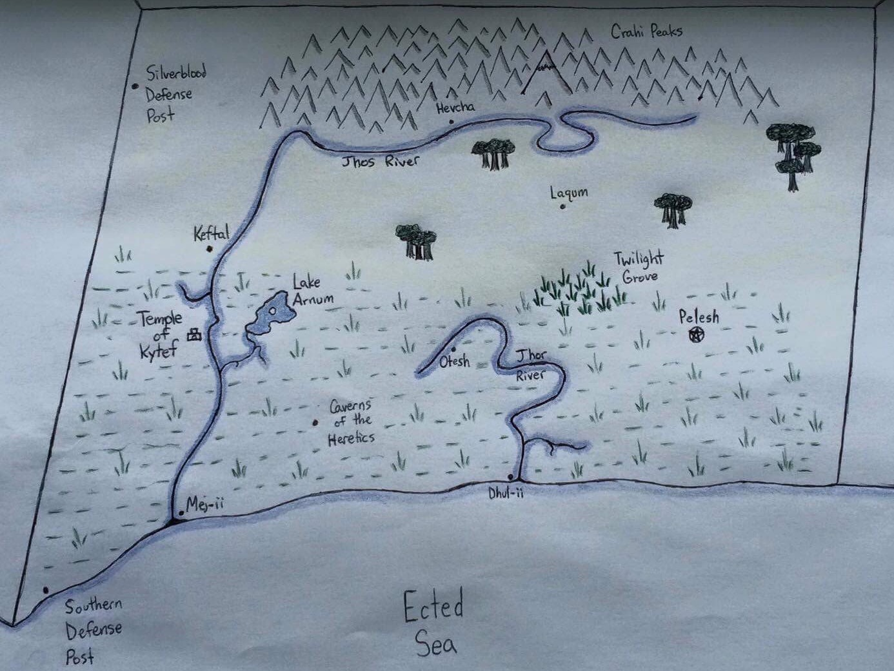

II

Historical Data

i

Humble Beginnings

The country now known as Pirudus began as a small community of nomads that had banded together in the western reaches of the Jhos River. Small settlements to the west of the river expanded into thriving areas, based around the agricultural viability of the river-plain regions. The establishment of the Tef religion around the ancient rock formations in the area, based on the worship of a long-believed cryptid, further advanced society and instilled a sense of purpose into the citizens of the country.

It was not long before the desires for expansion ached in the bones of the leaders, and exploration missions were sent out. Over the course of the next few decades, Pirudus grew into a nation, whose borders stretched from the Silverblood highlands to the Sindorian jungles. The land was broken into five provinces, and joined in an oligarchic government housed in Pelesh. They were, and still are, as follows:

1. Western Zonyan Province
   1. Controls the Jhor River, with its capitol city being Otesh.
   2. Leader’s title is “Jhor-XXX”.
2. Eastern Zonyan Province
   1. Controls the eastern marshes, with its capitol city being Pelesh.
   2. Leader’s title is “Pel-XXX”.
3. Ancient’s Bog Province
   1. Controls the Kytef Temple, with its capitol city being Keftal.
   2. Leader’s title is “Tef-XXX”.
4. Central Plains Province
   1. Controls a majority of the Jhos River, with its capitol city being Laqum.
   2. Leader’s title is “Laq-XXX”.
5. Northern Mountain Province
   1. Controls the Cranhi Peaks, with its capitol city being Hevcha.
   2. Leader’s title is “Cha-XXX”.

As the provinces developed and furthered their economic prosperity, trade increased between them and the bordering countries. Armies were raised and border defenses were constructed, all in favor of increasing the fledgling country’s security. Pirudus was in a state of social and economic prosperity.

ii

The Tef Uprising

During a particularly cold autumn, a small portion of the Tef Clergy were stricken with a terrible illness. Eventually becoming known as Ky’s Plague, the disease attacked the lungs, causing death through asphyxiation. Archwitness Meq and a number of his bishops were dead in a matter of days. Bishop Ler, the eldest of the remaining bishops, was immediately elected as the succeeding Archwitness. Under his rule, he condemned the arrival of the plague as a result of harsh mining practices in the north. Claiming that these mining methods were against the design of Ky, he demanded the immediate halting of all mining until they could be resolved and threatened hostile actions if his word was not heeded.

The elected heads of the United Federation of Pirudus [UFP] challenged these threats without delay. Save for the representative of the Ancient’s Bog, Tef-Ka, the oligarchy ruled in favor of discreet military action to silence the Archwitness. Mid-Winter, Archwitness Meq was assassinated. Unexpectedly for the oligarchy, his death resulted only in cries of martyrdom from the zealous members of Pirudian society. By the spring, Deacons led Tef citizens in marches upon Pelesh, demanding justice for the Archwitness and for the end of the northern mining. The city streets became a blood-bath, as the paranoid Military Council ordered the citizens to be cut down.

Over the next coming months, the Tef war machine attacked and besieged Pelesh in hopes of forcing the leaders to submit to their demands. The Military Council beat them back, time after time, wave after wave, until the armies of Pelesh chased the zealots back to the Ancient’s Bog. War was waged for weeks in battles of attrition, fighting across the river and with small land skirmishes in attempts to gain ground. After a particularly daring raid on a Tef camp at dusk, the remaining religious forces were pushed back, forced to garrison inside the temple itself. Surrounded and outnumbered, the temple was reduced to ruin over the course of a month. The Tef Clergy surrendered, leading to the imprisonment of many of its members. Some were not so lucky, as was with the case of Archwitness-elect Bor. Those whom the Military Council viewed as threats were silenced.

iii

Peace

Following the uprising of the Tef regime, and its subsequent quelling, Pirudus enjoyed a period of peace. Despite the claims of Archwitness Ler, Ky’s Wrath was not inflicted by the continuity of the northern mining. The Temple of Kytef was repaired and added to as the religion got back on its feet. Economic prosperity continued with bountiful harvests and international trade.

III

UFP Legends

i

Ky

A story passed down from elders of the nomadic tribes who colonized modern Pirudus described a beast living in the Ancient’s Bog. Witnesses to this beast claimed it to be nothing more than a common Mire Snake, if a Mire Snake’s diameter was the height of a man. Early depictions of Ky are often accompanied by descriptions of the beast’s immeasurable length, said to run underneath the entirety of the swamps themselves. Claims of Ky’s head say it has two sets of eyes on either side of its head, with a maw big enough to fit an ox. A fifth eye atop it’s head is said to be glassy and ensnaring. Nightmares are visited by those unlucky enough have gazed upon it, plagued by the link it creates with Ky’s ancient knowledge. A link to Ky, however, is a requirement of those wishing to seek a chance to become a member of the Tef Clergy.

It is often said by newcomers to the Temple of Kytef that the mountain it resides in bears a striking resemblance to nomadic depictions of Ky. The belief of many high-ranking Tef clergy members is that the near-hollow mountain is a result of Ky shedding its skin, which turned to stone upon its leaving. Sightings of Ky in recent times are surprisingly just as prevalent as they have been throughout the centuries, and are critical to members of the clergy. Often called Seer Paths, Tef Clergy must walk alone along the shores of Lake Arnum once a year, to seek enlightenment and Ky’s knowledge. It should be emphasized that the UFP flag is styled in accordance with the appearance of Ky’s head.

ii

Larat-Ky

As the existence of Ky has been, disputed amongst citizens of Pirudus, so too has the existence of its greatest enemy: Larat-Ky. According to nomadic legend, Pirudus suffered a terrible drought during one summer centuries ago. As the protector of the swamps and lands, Ky called upon the powers of the sky and conjured a thunderstorm so vast that it covered the entirety of the plains and the swamps, and even into the Ected Sea. Unyielding rainfall persisted for days, its thunderous storming echoing across the plains. Inspecting the volume of the swamps, Ky was stricken by a bolt of lightning. Its bellows of pain are claimed to have been heard as far as Mount Cranhi. It burrowed into the ground, in a place now known as the Caverns of the Heretics. Here, deep underground, it is said that Ky gave birth to a charred and disfigured Bog Squid before returning to Lake Arnum and relinquishing the storms.

Larat-Ky is revered as the child of both Ky and the sky itself. A being of primordial power, Larat-Ky is described as an oversized Bog Squid, it’s massive tentacles pulling it across land and moving it through water with equal ease. Paintings depict the beast as being deep-gray, with one of its two eyes gouged and perpetually oozing primeval liquid. Being banished to the Caverns of the Heretics is almost certainly a death sentence, as it is believed to be where Larat-Ky calls home.